Tab 1

**Chapter 1: Physical Quantities**

**All Lectures Uploaded on Youtube:**

[**https://tinyurl.com/fkm9-physics**](https://tinyurl.com/fkm9-physics)



**Physics:** It is the study of matter, energy and their interaction which defines the laws of nature and surroundings.

**Branches of Physics**

**1. Atomic and Nuclear Physics -** This is a branch of physics that deals with the study of Radioactivity and Nuclear Weapons

**2. Electromagnetism -** Electricity and Magnets

**3. Mechanics -** Laws of Nature

**4. Optics -** Glass

**5. Oscillations and Waves -** Travel of Light, Sound and Energy

**6. Quantum Physics -** Study of Energy and Matter at most Fundamental Levels

**7. Relativity -** Time and Space

**8. Thermodynamics -** Heat Energy and Temperature

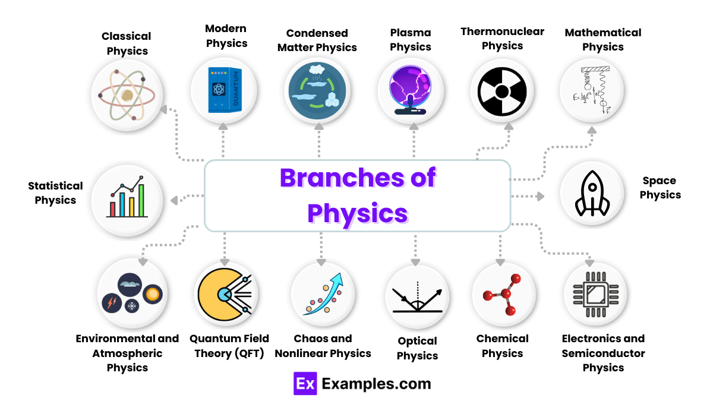

**Physical Quantities:** Quantities that can be measured. It is expressed as a magnitude (number) and a unit. (E.g. 10 kg, 30 second).

There are two types:

**1. Base -** Time, Mass, Length.

**2. Derived -** Weight, Force, Speed

**Non-Physical Quantities:** Quantities that can’t be measured. *Example:* Color.

***SI Units (System International):* French System for Measuring Units.**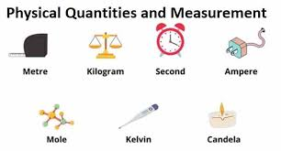

**SI Base Units:**

**1. Amount of substance (n) -** mole (mol),

*e.g. 6 mol - 6 moles*

**2. Electric Current (I) -** Ampere (A).

*e.g. 4 A - 4 Ampere*

**3. Length (l) -** Meter (m).

*e.g. 2 m - 2 meter*

**4. Light Intensity (Iv) -** Candela (cd)

*e.g. 15 cd - 15 Candela*

**5. Mass (m) -** Kilogram (kg),

*e.g. 70 kg - 70 Kilogram*